**P-P and Q-Q Plot:**

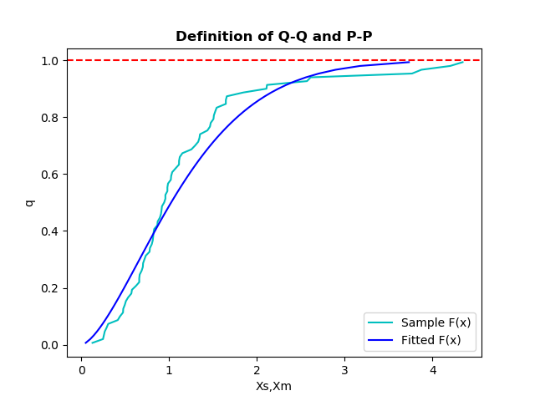

Here we have plotted the a graph for quantile vs sample **Xs**, fitted **Xm** to see how sample distribution and fitted distribution behave.